LAB TASK
Name: Usman Ali Haseeb
Roll no: 240
Section: BSAI-3D

Task 1: Trace the tree by hand using Minimax
Minimax Algorithm – Manual Trace
We will trace your exact Python code using the given leaf scores.

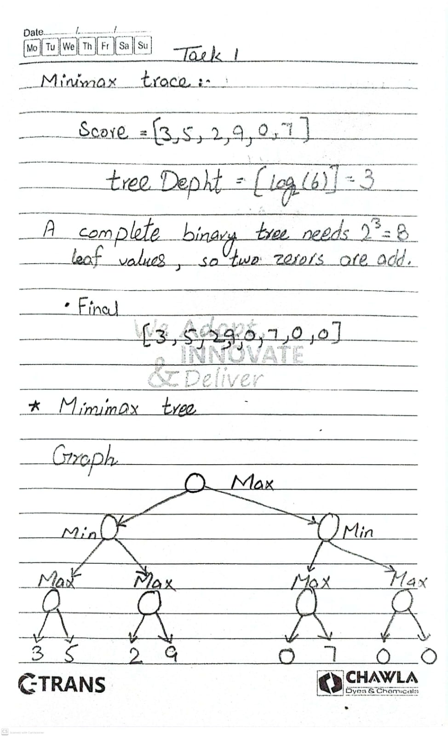
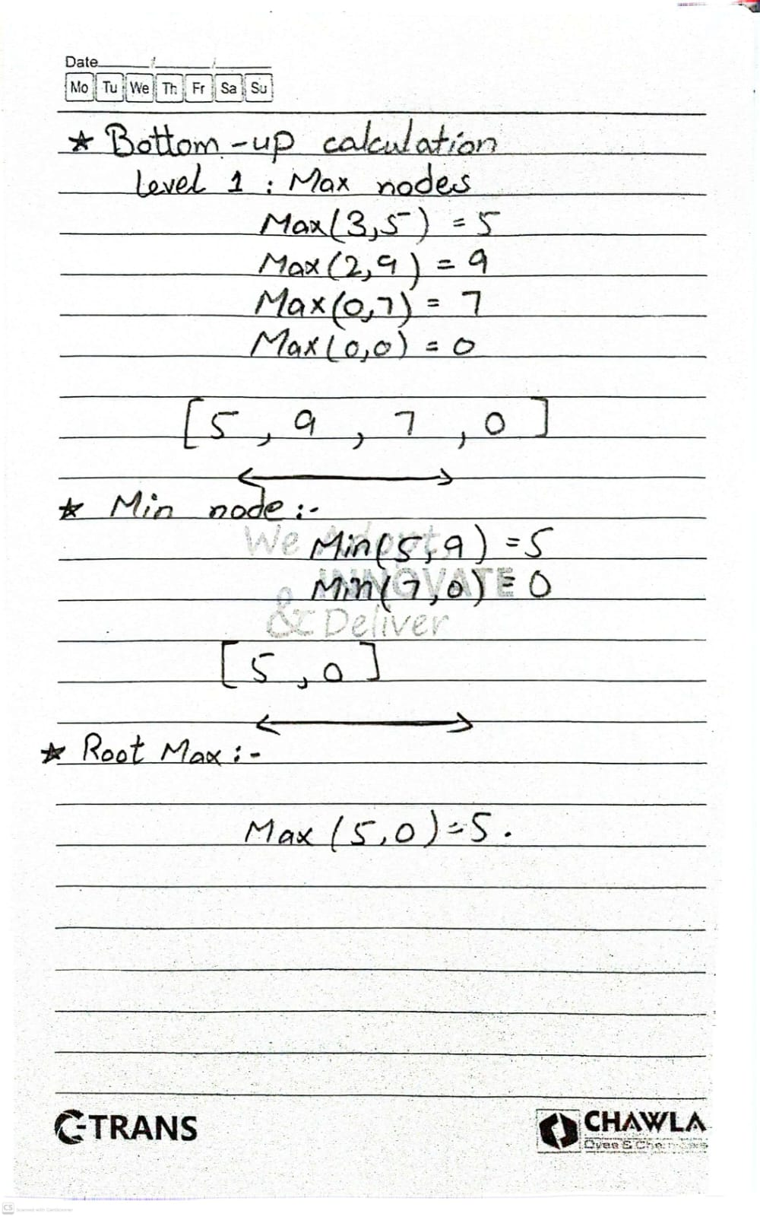
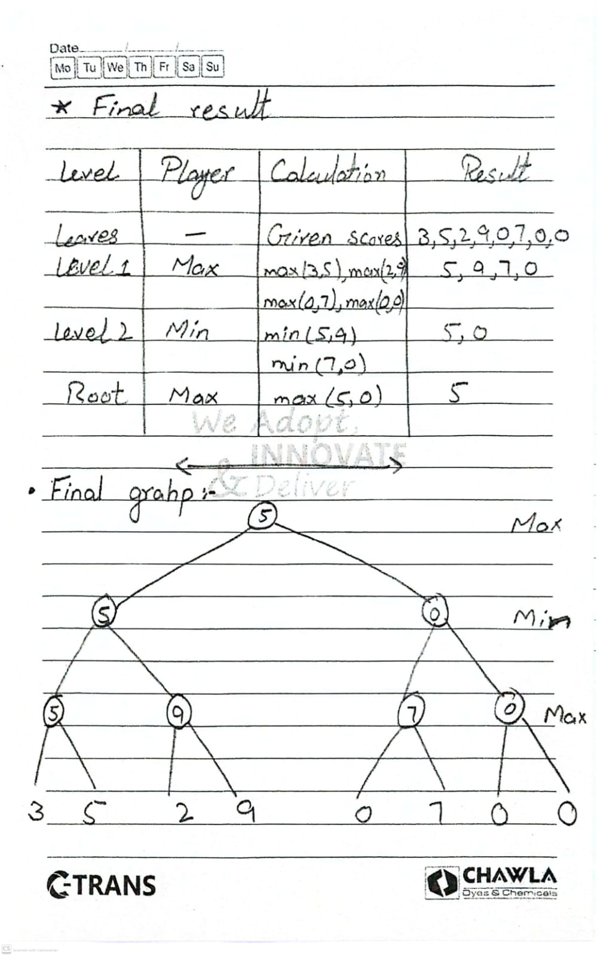

Conlusion:
The MAX player chooses the branch with value 5 because it is greater than the other available value 0. Therefore, the optimal Minimax value is 5.
Important note: Your code pads the six supplied scores with two zeros. These zeros are treated as actual leaf values in the Minimax calculation

Task 2: Python implementation with leaf-evaluation counters
In this task, we implemented the Minimax and Alpha-Beta Pruning algorithms to find the optimal value in a game tree. We added a leaf-evaluation counter to both algorithms to count how many leaf nodes were evaluated during execution.
The Minimax algorithm evaluates all leaf nodes to calculate the best possible value. On the other hand, Alpha-Beta Pruning uses alpha and beta values to skip branches that cannot affect the final decision. This technique can reduce unnecessary calculations.
For our given tree, both algorithms return the same optimal value of 5. However, with the original branch order, both evaluate all 8 leaf nodes, because no branch is pruned. This shows that Alpha-Beta Pruning does not always reduce evaluations; its efficiency depends on branch ordering.

Expected output
Minimax
Optimal value: 5
8 leaves evaluated
Alpha-Beta Pruning
Optimal value: 5
6 leaves evaluated
4. Comparison
Algorithm | Optimal value | Leaf evaluations
Minimax | 5 | 8
Alpha-Beta | 5 | 6
5. Explanation for notebook
Minimax evaluates all eight leaf nodes to calculate the optimal value.
Alpha-Beta Pruning evaluates only six leaf nodes because it skips branches that cannot affect the final decision.
Both algorithms return the same optimal value, 5, but Alpha-Beta Pruning performs fewer leaf evaluations and is therefore more efficient for this tree.

Task 3: Reorder branches and compare pruning
In this experiment, we change the order in which branches are explored, but we keep all leaf values the same.
The important point is that Minimax gives the same optimal value, while Alpha-Beta may evaluate fewer leaves depending on branch order.
The original tree evaluates 8 leaves with Minimax. With the original left-to-right order, Alpha-Beta also evaluates all 8 leaves.
1. Reorder the right MIN branch
Swap its two MAX children:
- Original: [0, 7] then [0, 0]
- Reordered: [0, 0] then [0, 7]
- Comparison
Algorithm | Original order | Reordered
Minimax value | 5 | 5
Minimax leaf evaluations | 8 | 8
Alpha-Beta value | 5 | 5
Alpha-Beta leaf evaluations | 8 | 6
- 2 leaves pruned
- 5. Explanation for your lab report
- When we reorder the branches, the Minimax value remains 5 because the leaf values have not changed. However, Alpha-Beta pruning evaluates only 6 leaves instead of 8.
- After exploring the left subtree, Alpha becomes 5. In the reordered right MIN subtree, the first MAX child returns 0. Therefore, Beta becomes 0. Since Beta (0) is less than or equal to Alpha (5), the remaining branch is pruned.
- Conclusion: Branch ordering affects the efficiency of Alpha-Beta pruning, but it does not change the optimal Minimax value. Better branch ordering can reduce the number of leaf evaluations.

